**Wei Liang** **SP17**

**CST 2309-E286**

**Lab#2**

**Prof. Sancar Avcioglu Feb 6, 2017**

**Lab2:**

1. Create an HTML file that displays the image <http://www.websitedevelopmentbook.com/Chapter02/Cat.jpg>

2. Use the HTML <img> tag height and width attributes within an HTML file to display the following image sized at 300 by 300:

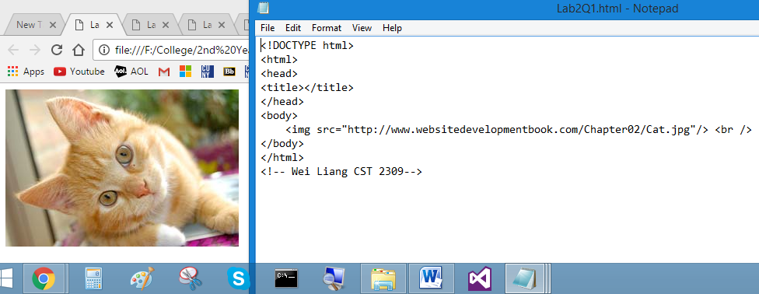

<http://www.websitedevelopmentbook.com/Chapter02/Ball.jpg>

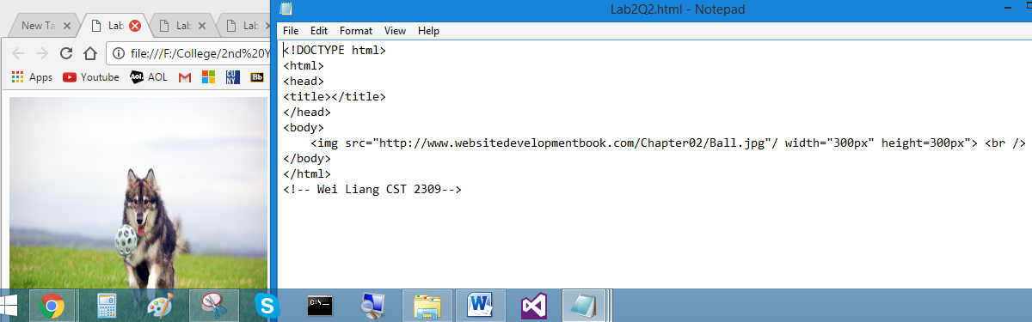

3. Use the HTML <img> tag height and width attributes within an HTML file to display the following image sized at various percentages of the current browser window size: <http://www.websitedevelopmentbook.com/Chapter02/Flag.jpg>

4. Create an HTML file that centers the image at <http://www.websitedevelopmentbook.com/Chapter02/Car.jpg>

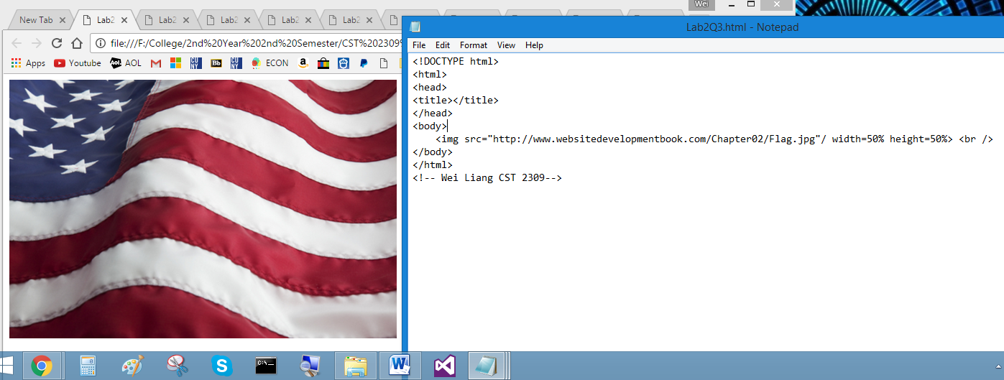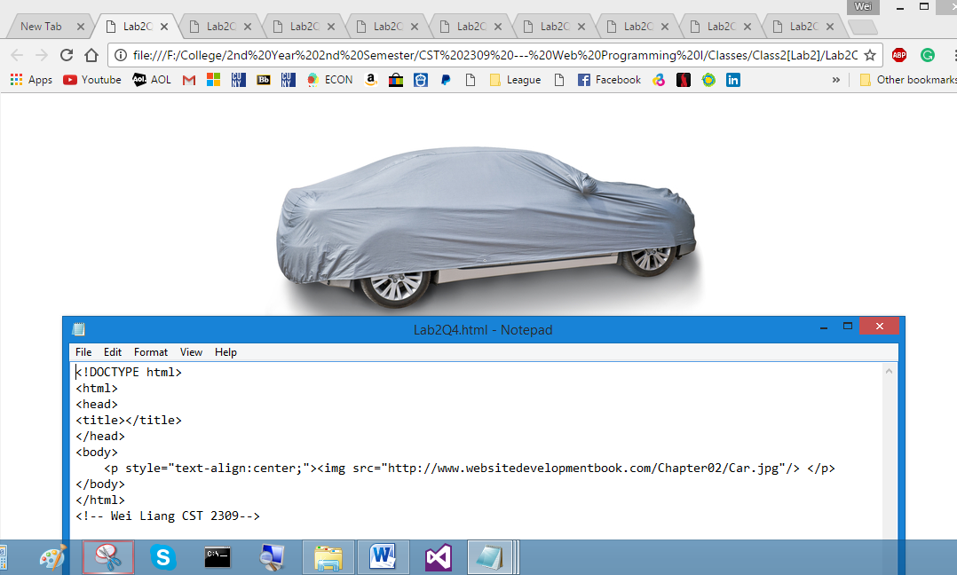

5. Create an HTML file that displays the animated GIF image <http://www.websitedevelopmentbook.com/Chapter02/Barkingdog.gif>

6. Use the <body> tag to fill the page background with the following image:

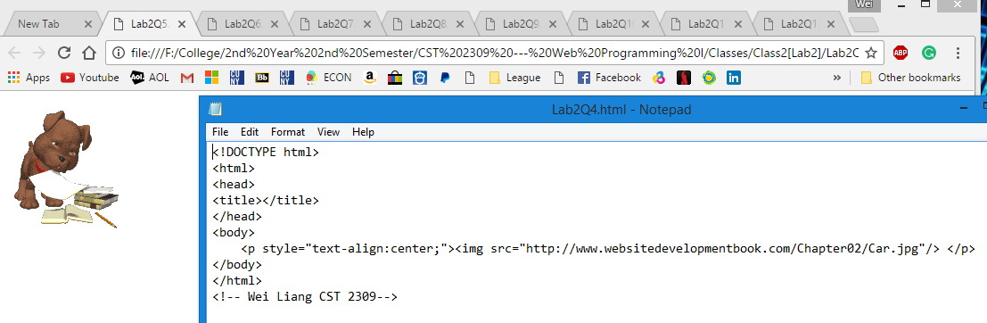

(Changed SRC)<http://54.214.29.39/chapter02/smiley.jpg>

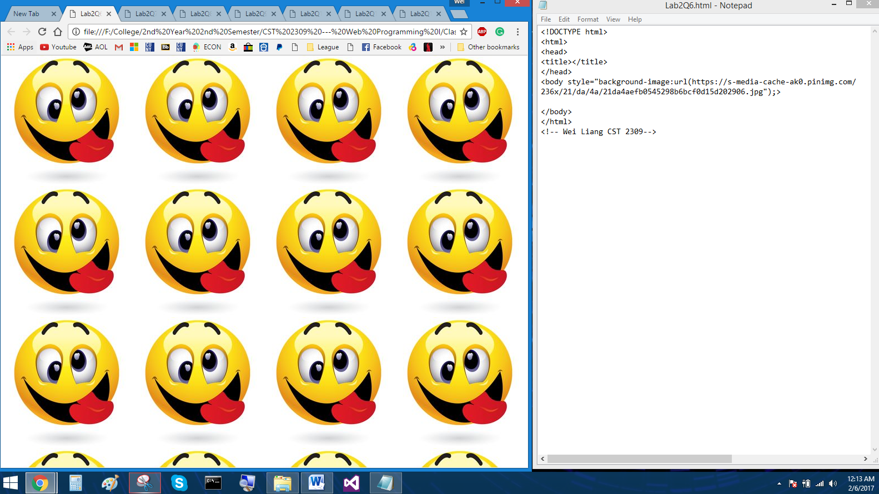

7. Using image positioning, stack the following image files within a webpage:  
<http://www.websitedevelopmentbook.com/Chapter02/Dog01.jpg>  
<http://www.websitedevelopmentbook.com/Chapter02/Dog02.jpg>  
<http://www.websitedevelopmentbook.com/Chapter02/Dog03.jpg>

8. Create an HTML file that displays a border around the following image, and display the image centered in the page: <http://www.websitedevelopmentbook.com/Chapter02/Dog.jpg>

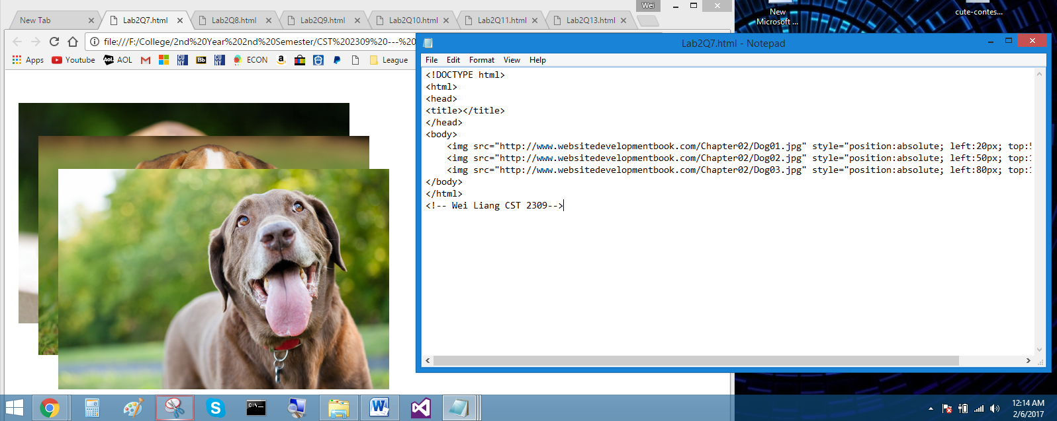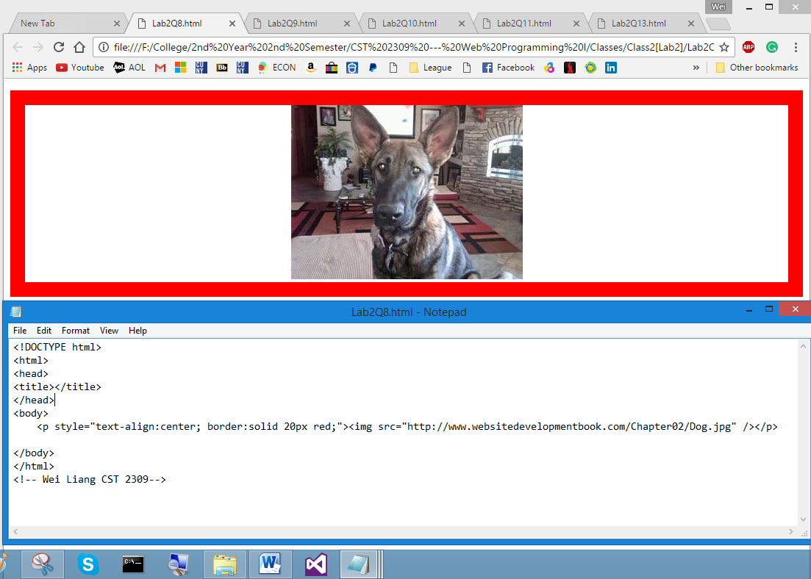

9. Modify the HTML file you created in Question 8 to display the image with rounded corners.

10. Create an HTML file that rotates the following image at different angles within an HTML page: (Changed SRC)<http://www.websitedevelopmentbook.com/Chapter02/Airplane.jpg>

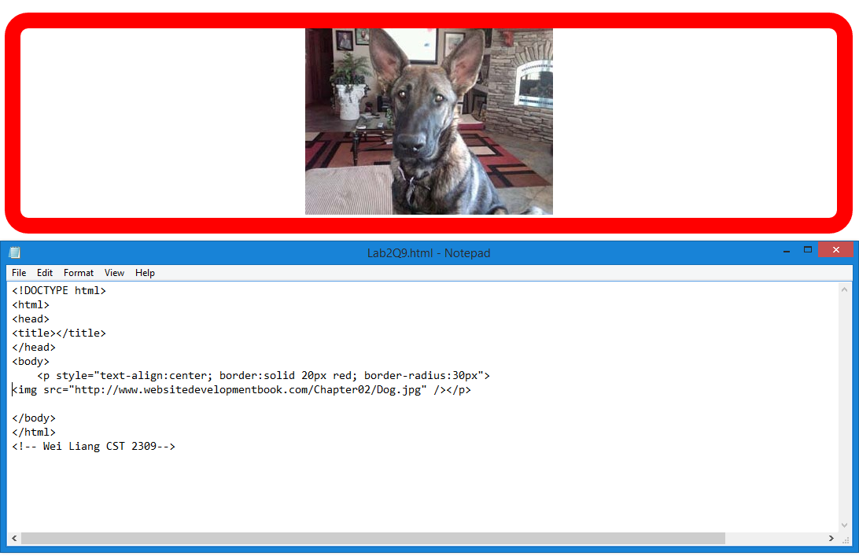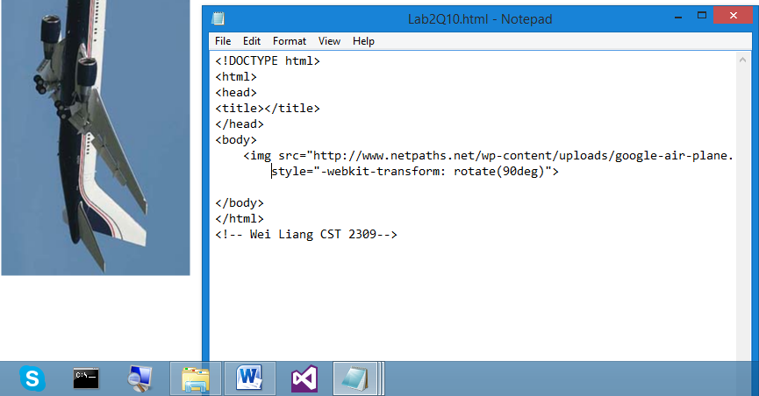

11. Create an HTML file that displays the following images side by side with a 20-pixel padding around the images:  
<http://www.websitedevelopmentbook.com/Chapter02/Dog01.jpg>  
<http://www.websitedevelopmentbook.com/Chapter02/Dog02.jpg>  
<http://www.websitedevelopmentbook.com/Chapter02/Dog03.jpg>

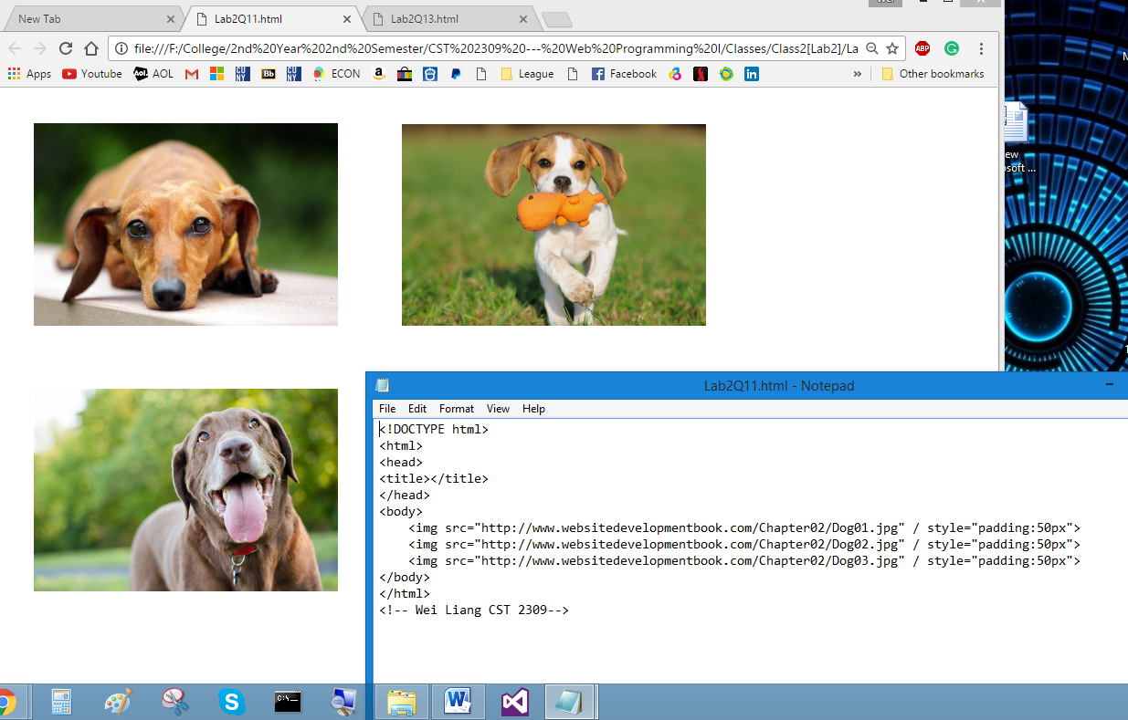  
12. Describe the role of the <img> tag alt attribute with respect to screen readers.

The usage of the alt attribute in the <img> tag provides alternative information for an image if a user is unable to view it either due to slow connection, an error within the source code or the screen reader. In short, if an image cannon be displayed, the alt attribute specifies an alternative text for an image.

13. Create an HTML file that displays the following image using a variety of opacities: <http://www.websitedevelopmentbook.com/Chapter02/Dog.jpg>

